Die casting manufacturer in Ningbo China
YIZUMI Cold chamber die casting machines of 280tons, 400tons, 500tons and 800tons.
2000 square meters precision machining workshop with 4-axes machining center
Professional die casting mold factory and post treatment partners

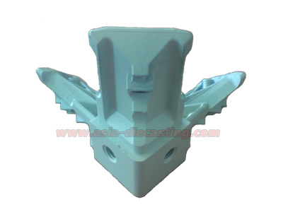
Product name: zinc die cast bracket-03
Product series: zinc die casting series
Die casting material:AZ4-1
Die casting mold lead time: 25 days
Casting die cavity number: 2 cavities
Service time of casting die: 50000-70000 shots
Tonnage of die casting machine: 280 tons
CNC machining: turning
Post treatment: none
Exporting country: USA

