Die casting manufacturer in Ningbo China
YIZUMI Cold chamber die casting machines of 280tons, 400tons, 500tons and 800tons.
2000 square meters precision machining workshop with 4-axes machining center
Professional die casting mold factory and post treatment partners

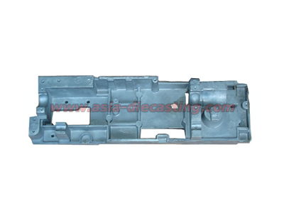
Product name: die cast sartorius housing
Product series: die cast sartorius housing series
Die casting material: ADC-12
Die casting mold lead time: 25 days
Casting die cavity number: 1 cavity
Service time of casting die: 50000-70000 shots
Tonnage of die casting machine: 800 tons
CNC machining: tapping and milling by machining center
Post treatment: none
Exporting country: USA

