Die casting manufacturer in Ningbo China
YIZUMI Cold chamber die casting machines of 280tons, 400tons, 500tons and 800tons.
2000 square meters precision machining workshop with 4-axes machining center
Professional die casting mold factory and post treatment partners

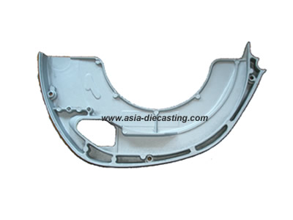
Product name: die cast electronic saw cover-01
Product series: die cast appliance part series
Die casting material: ACD-12
Die casting mold lead time: 25 days
Casting die cavity number: 1 cavities
Service time of casting die: 50000-70000 shots
Tonnage of die casting machine: 280 tons
CNC machining: tapping and milling
Post treatment: powder coating
Exporting country: Japan

