Die casting manufacturer in Ningbo China
YIZUMI Cold chamber die casting machines of 280tons, 400tons, 500tons and 800tons.
2000 square meters precision machining workshop with 4-axes machining center
Professional die casting mold factory and post treatment partners

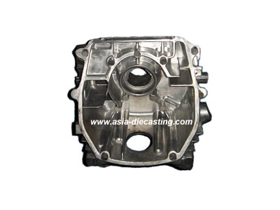
Product name: die cast cylinder header-04
Product series: die cast motorcycle part series
Die casting material: ACD-12
Die casting mold lead time: 35 days
Casting die cavity number: 1 cavities
Service time of casting die: 50000-70000 shots
Tonnage of die casting machine: 400 tons
CNC machining: by machining center
Post treatment: impregnation
Exporting country: Local market

